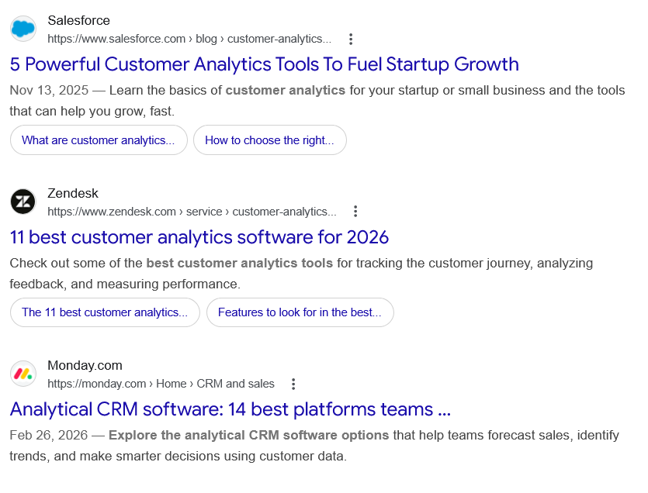
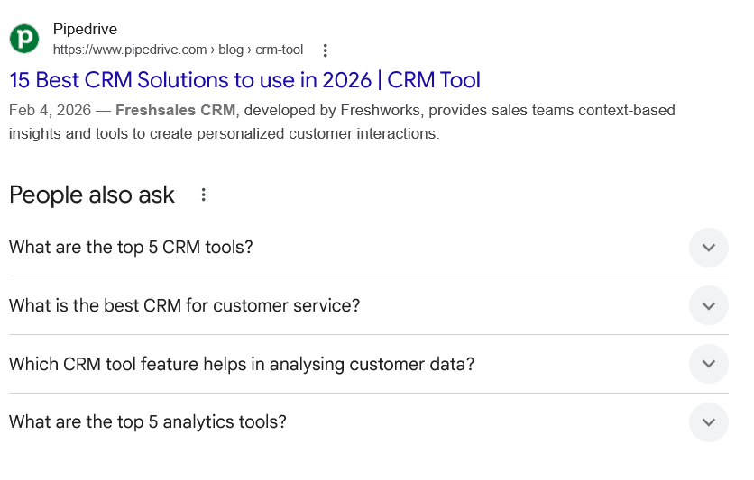
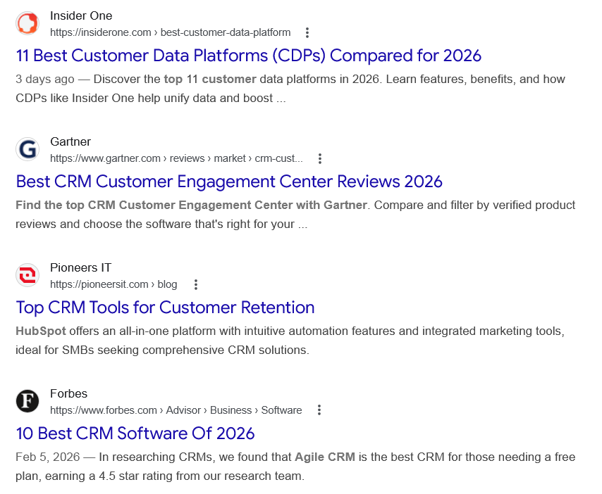
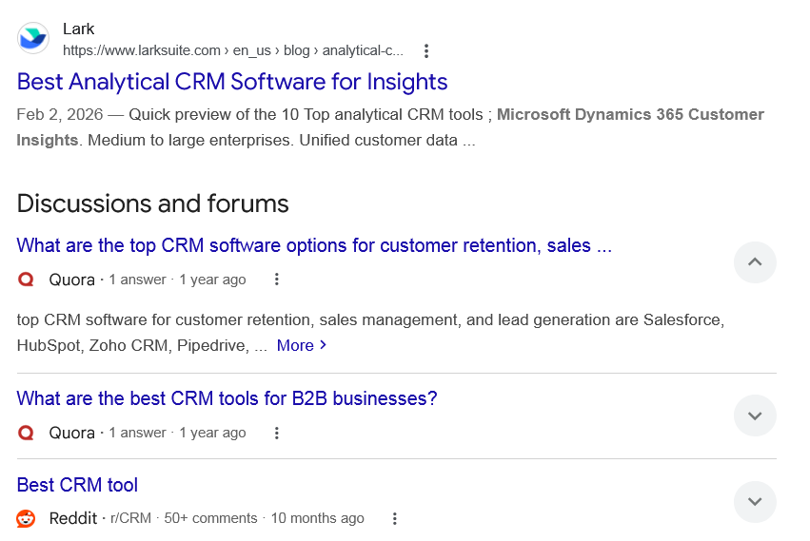
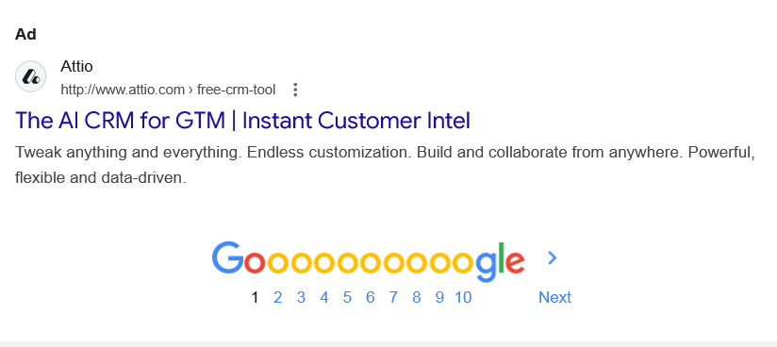

Web results

5 Powerful Customer Analytics Tools To Fuel Startup Growth

Salesforce
https://www.salesforce.com › blog › customer-analytics...

Salesforce
https://www.salesforce.com › blog › customer-analytics...
Nov 13, 2025 — Learn the basics of customer analytics for your startup or small business and the tools that can help you grow, fast.
•
What are customer analytics...

•
How to choose the right...

11 best customer analytics software for 2026

Zendesk
https://www.zendesk.com › service › customer-analytics...

Zendesk
https://www.zendesk.com › service › customer-analytics...
Check out some of the best customer analytics tools for tracking the customer journey, analyzing feedback, and measuring performance.
•
The 11 best customer analytics...

•
Features to look for in the best...

Analytical CRM software: 14 best platforms teams ...

Monday.com
https://monday.com › Home › CRM and sales

Monday.com
https://monday.com › Home › CRM and sales
Feb 26, 2026 — Explore the analytical CRM software options that help teams forecast sales, identify trends, and make smarter decisions using customer data.

15 Best CRM Solutions to use in 2026 | CRM Tool

Pipedrive
https://www.pipedrive.com › blog › crm-tool

Pipedrive
https://www.pipedrive.com › blog › crm-tool
Feb 4, 2026 — Freshsales CRM, developed by Freshworks, provides sales teams context-based insights and tools to create personalized customer interactions.
People also ask
What are the top 5 CRM tools?

The best CRM software
- Salesforce Sales Cloud for extensibility.
- HubSpot for versatility.
- Zoho CRM for AI features.
- Pipedrive for ease of use.
- Ontraport for automating online transactions.
- Nimble for prospecting.
- Membrain for designing sales processes.
- Salesmate for customizability.
More items...
•
May 15, 2025

The 12 best CRM software - Zapier

Zapier
https://zapier.com › blog › best-crm-app

Zapier
https://zapier.com › blog › best-crm-app
What is the best CRM for customer service?
- monday CRM. Use case: Flexible AI CRM that improves service levels. ...
- HubSpot Smart CRM. Use case: Robust CRM with great marketing and sales tools. ...
- Zoho CRM. Use case: User-friendly platform for building lasting customer relationships. ...
- Salesforce Sales Cloud. ...
- Creatio CRM. ...
- SAP Sales Cloud.
Jan 5, 2026

6 top CRMs for service businesses in 2026 and how to choose the right one

Monday.com
https://monday.com › blog › crm-for-service-business

Monday.com
https://monday.com › blog › crm-for-service-business
Which CRM tool feature helps in analysing customer data?
Analytical CRM systems specialize in generating insights and identifying patterns and trends associated with customer behavior, preferences, and purchases. They help sales, marketing, and service teams better understand customers and make more informed decisions.

What is CRM? | Microsoft Dynamics 365

Microsoft
https://www.microsoft.com › dynamics-365 › resources

Microsoft
https://www.microsoft.com › dynamics-365 › resources
What are the top 5 analytics tools?
Leading analytics tools include Helical Insight, Power BI, Tableau, Looker, Qlik Sense, Sisense, Domo, Metabase, Google Data Studio, and Zoho Analytics. These platforms help businesses extract insights from data through interactive dashboards and reports.Jan 10, 2025

Top 10 Analytics Tools for 2026 - Helical Insight

Helical Insight
https://www.helicalinsight.com › top-10-analytics-tools-f...

Helical Insight
https://www.helicalinsight.com › top-10-analytics-tools-f...

Web results

11 Best Customer Data Platforms (CDPs) Compared for 2026

Insider One
https://insiderone.com › best-customer-data-platform

Insider One
https://insiderone.com › best-customer-data-platform
3 days ago — Discover the top 11 customer data platforms in 2026. Learn features, benefits, and how CDPs like Insider One help unify data and boost ...

Best CRM Customer Engagement Center Reviews 2026

Gartner
https://www.gartner.com › reviews › market › crm-cust...

Gartner
https://www.gartner.com › reviews › market › crm-cust...
Find the top CRM Customer Engagement Center with Gartner. Compare and filter by verified product reviews and choose the software that's right for your ...

Top CRM Tools for Customer Retention

Pioneers IT
https://pioneersit.com › blog

Pioneers IT
https://pioneersit.com › blog
HubSpot offers an all-in-one platform with intuitive automation features and integrated marketing tools, ideal for SMBs seeking comprehensive CRM solutions.

10 Best CRM Software Of 2026

Forbes
https://www.forbes.com › Advisor › Business › Software

Forbes
https://www.forbes.com › Advisor › Business › Software
Feb 5, 2026 — In researching CRMs, we found that Agile CRM is the best CRM for those needing a free plan, earning a 4.5 star rating from our research team.

Best Analytical CRM Software for Insights

Lark
https://www.larksuite.com › en_us › blog › analytical-c...

Lark
https://www.larksuite.com › en_us › blog › analytical-c...
Feb 2, 2026 — Quick preview of the 10 Top analytical CRM tools ; Microsoft Dynamics 365 Customer Insights​. Medium to large enterprises​. Unified customer data ...
Discussions and forums

What are the top CRM software options for customer retention, sales ...
Quora ·
1 answer
· 1 year ago

What are the top CRM software options for customer retention, sales ...
Quora ·
1 answer
· 1 year ago
top CRM software for customer retention, sales management, and lead generation are Salesforce, HubSpot, Zoho CRM, Pipedrive, ... More

What are the best CRM tools for B2B businesses?
Quora ·
1 answer
· 1 year ago

What are the best CRM tools for B2B businesses?
Quora ·
1 answer
· 1 year ago
If you’re looking to improve your B2B business’ performance by investing in CRM software, you’re doing everything right! CRM software is a necessity ... More
Top answer · 3 votes · 5 years ago

Best CRM tool
Reddit ·
r/CRM
· 50+ comments
· 10 months ago

Best CRM tool
Reddit ·
r/CRM
· 50+ comments
· 10 months ago
Pick any CRM for SMBs like Pipedrive (exclusive 20% off for 1year), Hubspot (free plan), Capsule (free plan), Close (native calling and texting) ... More

See more

Ad

The AI CRM for GTM | Instant Customer Intel

Attio
http://www.attio.com › free-crm-tool

Attio
http://www.attio.com › free-crm-tool

My Ad Centre
Tweak anything and everything. Endless customization. Build and collaborate from anywhere. Powerful, flexible and data-driven.

